Whats on your hands?

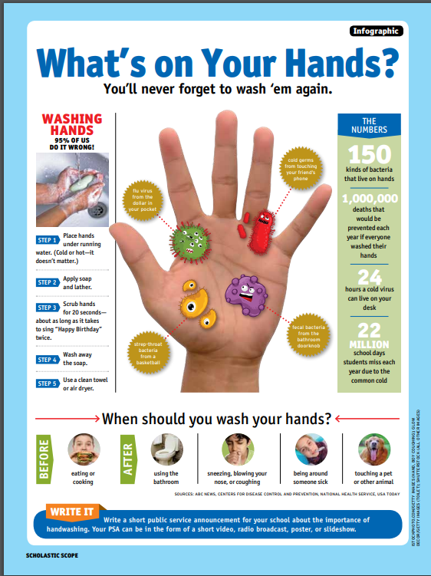
How many kinds of bacteria live on our hands? | 150
List two times you should wash your hands. | Before eating and after being around someone sick
When washing your hands, how many times should you sing “Happy Birthday”? | twice!
How many deaths per year could be prevented through hand washing? | 1000,000
What percentage of us are washing our hands wrong? | 95%

